Create Table Query for teachers
CREATE TABLE users (
id INT AUTO_INCREMENT PRIMARY KEY,
username VARCHAR(50) NOT NULL UNIQUE,
email VARCHAR(100) NOT NULL UNIQUE,
password VARCHAR(255) NOT NULL,
created_at TIMESTAMP DEFAULT CURRENT_TIMESTAMP
);

Create Table Query for automation_logs
CREATE DATABASE IF NOT EXISTS nmims_automation;
USE nmims_automation;

CREATE TABLE IF NOT EXISTS automation_logs (
id INT AUTO_INCREMENT PRIMARY KEY,
user_id INT NOT NULL,
classroom VARCHAR(10),
type ENUM('command', 'attendance') NOT NULL,
device VARCHAR(50),
action VARCHAR(50),
value TEXT,
batch VARCHAR(10),
present_rollnos TEXT,
timestamp DATETIME NOT NULL DEFAULT CURRENT_TIMESTAMP,
FOREIGN KEY (user_id) REFERENCES teachers(id) ON DELETE CASCADE
);

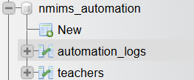

Queries on Xampp
SELECT
t1.id,
t1.fullname,
t1.email,
t1.sap_id,
t1.department,
t1.created_at,
(SELECT COUNT(*)
FROM teachers t2
WHERE t2.department = t1.department) AS total_teachers_in_dept,
(SELECT MIN(t3.created_at)
FROM teachers t3
WHERE t3.department = t1.department) AS earliest_joined_in_dept,
(SELECT MAX(t4.created_at)
FROM teachers t4
WHERE t4.department = t1.department) AS latest_joined_in_dept,
CONCAT(t1.fullname, ' (', t1.email, ')') AS name_email_combo,
DATEDIFF(CURDATE(), t1.created_at) AS days_since_joined
FROM
teachers t1
GROUP BY
t1.department, t1.id
ORDER BY
t1.department, t1.created_at DESC;
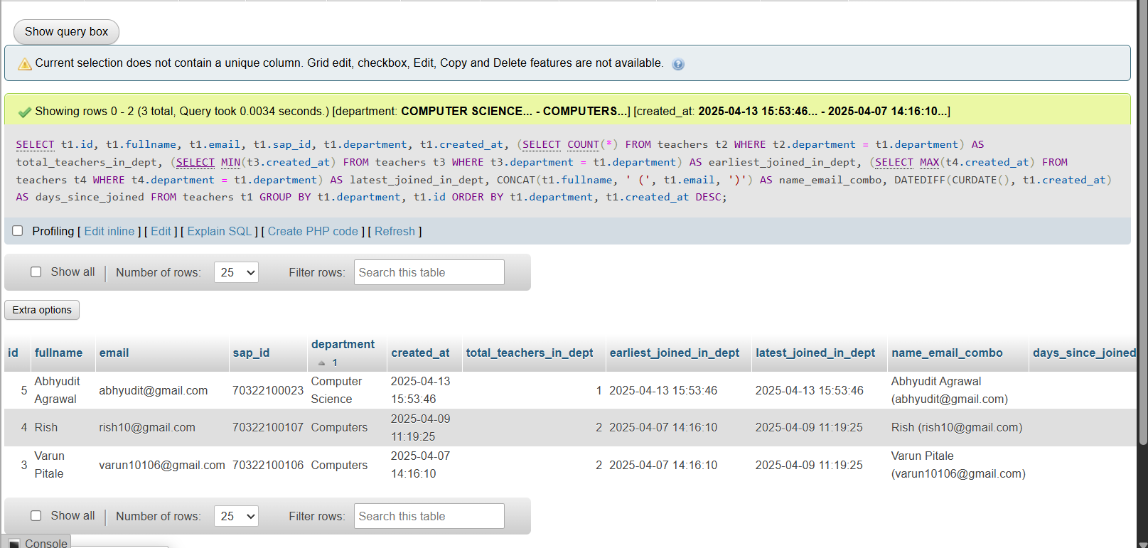

SELECT
t1.fullname AS teacher_1,
t1.email AS email_1,
t2.fullname AS teacher_2,
t2.email AS email_2,
SUBSTRING_INDEX(t1.email, '@', -1) AS domain_1,
SUBSTRING_INDEX(t2.email, '@', -1) AS domain_2,
TIMESTAMPDIFF(DAY, t1.created_at, t2.created_at) AS days_apart,
t1.department AS dept_1,
t2.department AS dept_2,
CONCAT('Joined on: ', DATE_FORMAT(t1.created_at, '%Y-%m-%d')) AS join_date_1,
CONCAT('Joined on: ', DATE_FORMAT(t2.created_at, '%Y-%m-%d')) AS join_date_2
FROM
teachers t1
CROSS JOIN
teachers t2
WHERE
t1.id != t2.id
AND SUBSTRING_INDEX(t1.email, '@', -1) = SUBSTRING_INDEX(t2.email, '@', -1)
ORDER BY
t1.created_at, t2.created_at;
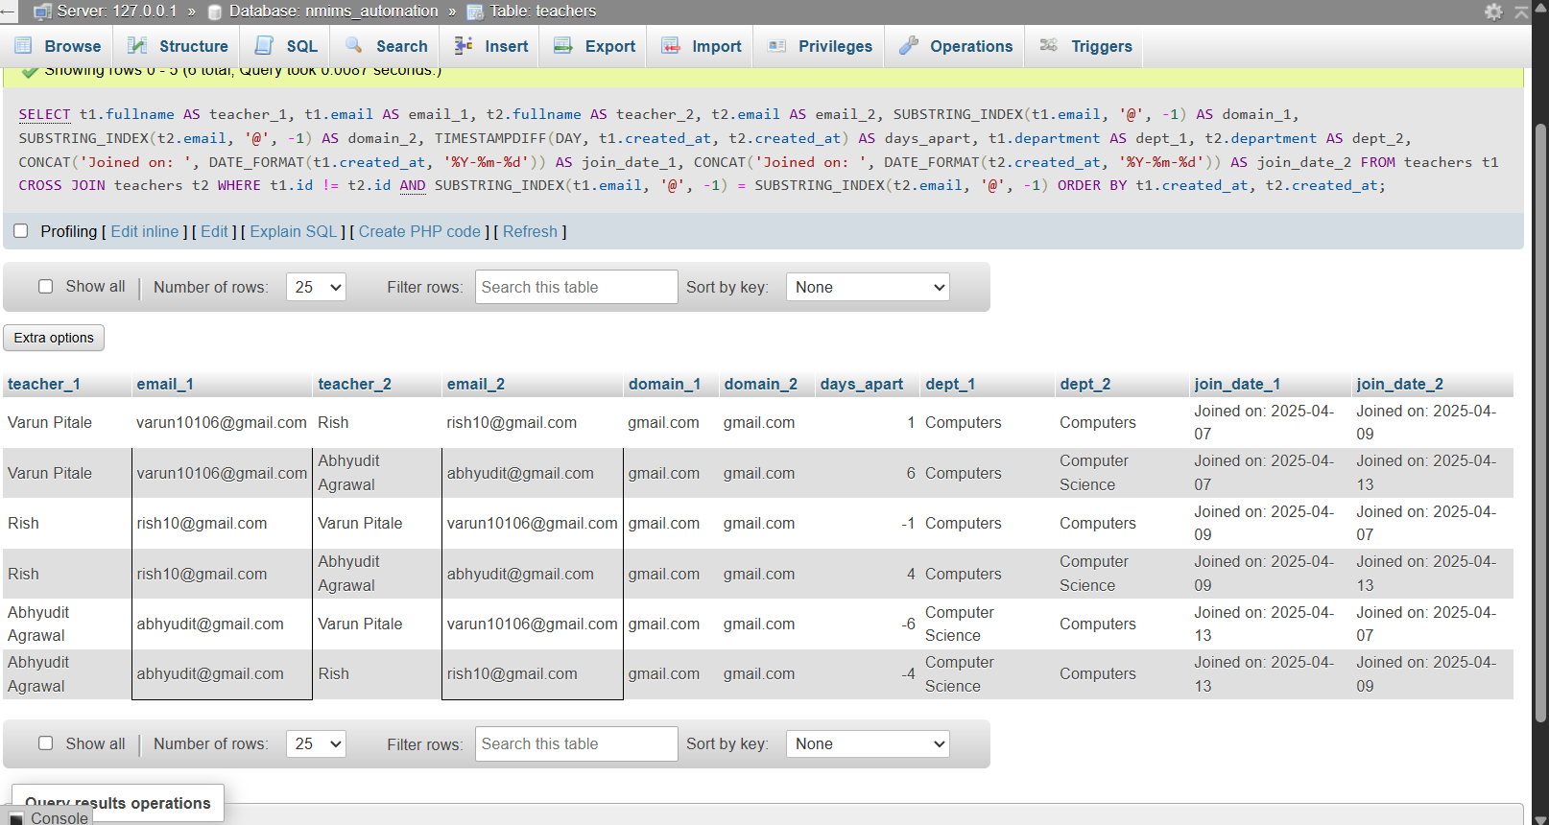
SELECT
DATE_FORMAT(t1.created_at, '%Y-%m') AS join_month,
COUNT(*) AS teachers_joined,
(SELECT COUNT(*)
FROM teachers t2
WHERE DATE_FORMAT(t2.created_at, '%Y%m') <= DATE_FORMAT(t1.created_at, '%Y%m')) AS running_total,
GROUP_CONCAT(t1.fullname ORDER BY t1.created_at) AS teacher_names,
GROUP_CONCAT(t1.email ORDER BY t1.created_at) AS teacher_emails,
MIN(t1.created_at) AS first_joined_in_month,
MAX(t1.created_at) AS last_joined_in_month
FROM
teachers t1
GROUP BY
DATE_FORMAT(t1.created_at, '%Y-%m')
ORDER BY
join_month;
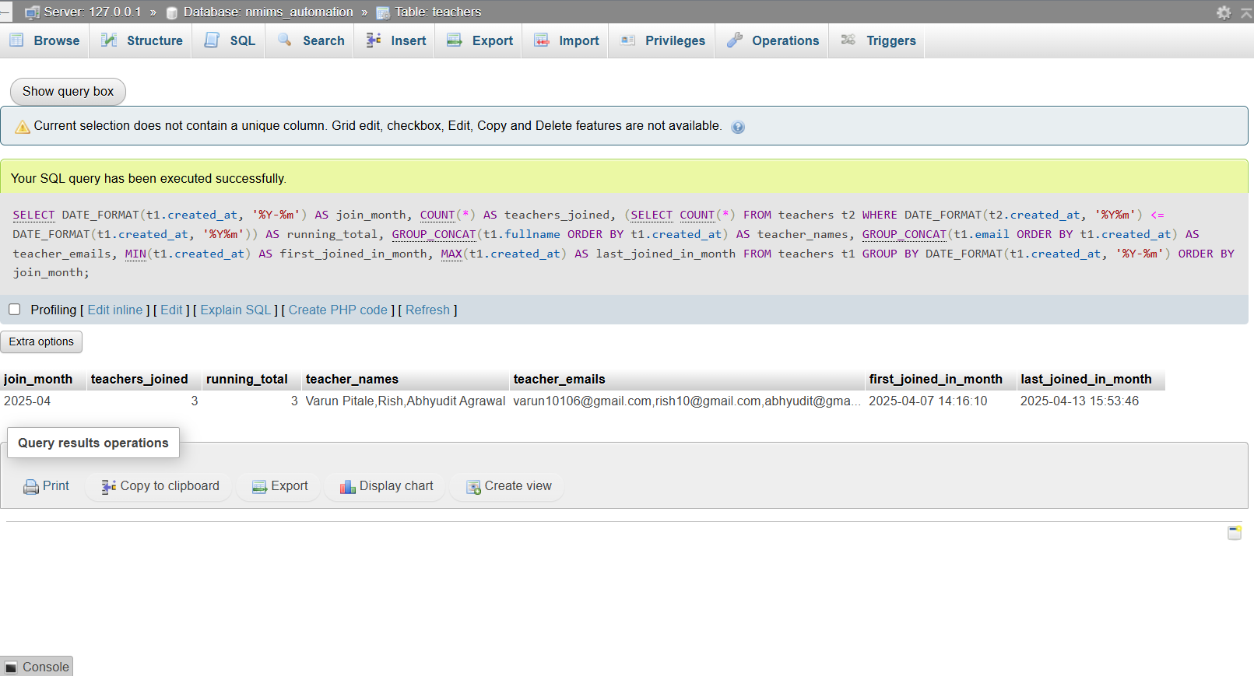
SELECT
t1.department,
t1.fullname,
t1.email,
t1.created_at,
(SELECT AVG(TIMESTAMPDIFF(DAY, t2.created_at, t3.created_at))
FROM teachers t2
CROSS JOIN teachers t3
WHERE t2.department = t1.department
AND t3.department = t1.department
AND t2.id < t3.id) AS avg_days_between_joins_in_dept,
(SELECT GROUP_CONCAT(t4.fullname ORDER BY t4.created_at)
FROM teachers t4
WHERE t4.department = t1.department) AS all_teachers_in_dept,
COUNT(*) OVER (PARTITION BY t1.department) AS total_in_dept
FROM
teachers t1
ORDER BY
t1.department, t1.created_at;
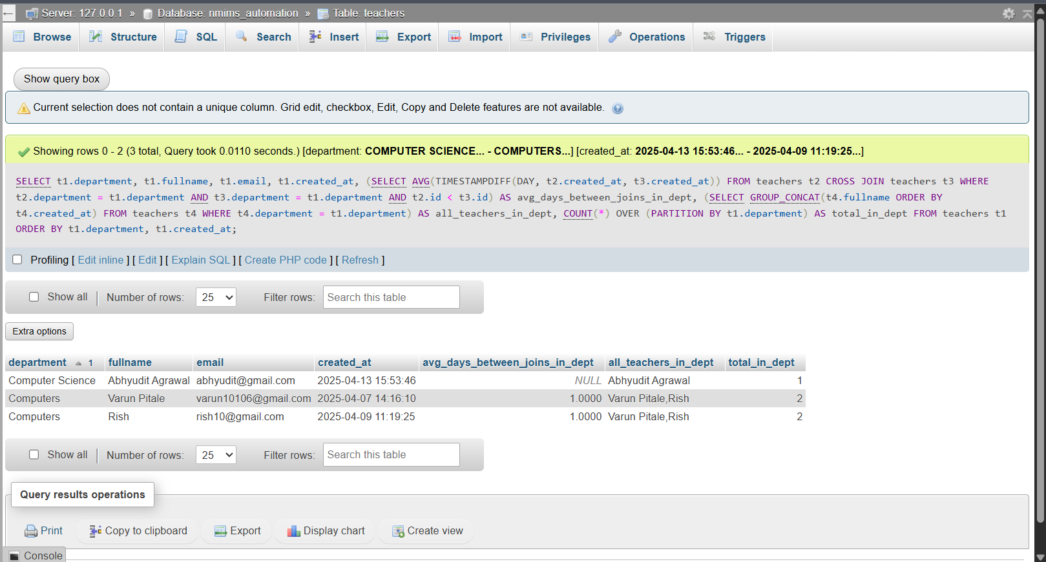

SELECT
id,
fullname,
email,
sap_id,
department,
created_at,
RANK() OVER (PARTITION BY department ORDER BY created_at) AS join_rank_in_dept,
DENSE_RANK() OVER (PARTITION BY department ORDER BY created_at) AS dense_join_rank_in_dept,
TIMESTAMPDIFF(HOUR, created_at, CURDATE()) AS hours_since_joined,
CONCAT(UPPER(LEFT(fullname, 1)), LOWER(SUBSTRING(fullname, 2))) AS formatted_name,
(SELECT COUNT(*)
FROM teachers t2
WHERE t2.department = t1.department
AND t2.created_at <= t1.created_at) AS teachers_before_this_one
FROM
teachers t1
ORDER BY
department, created_at;


